Random Character Generator

There are 3 scripts that should be attached to any character regardless of the random generator.

Stats/attributes/mods

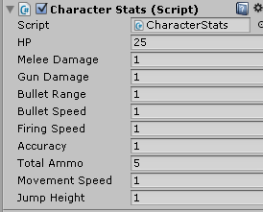 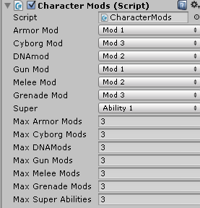 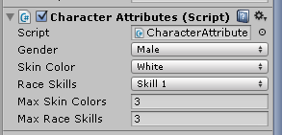

Each script can be easily adjusted for custom scenarios.

The generator accesses these scripts, and I used an additive algorithm for the stats so that you can set default values here and the generator will “add” to those values.

The scripts can also be used independently of the generator, that way you can make your own custom builds of characters.

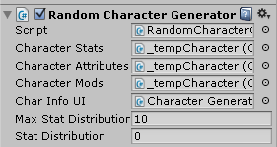This is the random character generator script. You can change the max amount of stats that it will distribute.

I also created a UI display script to display the random generation. This script can be easily integrated into any custom UI as it directly references the UI text as seen below. See the next page for an example of usage.

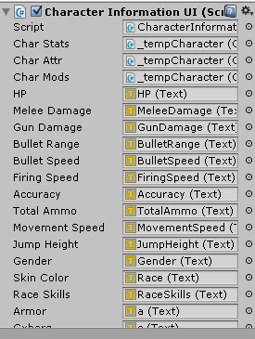

Random Generator Usage

This is what the default state looks like before you press “random character”

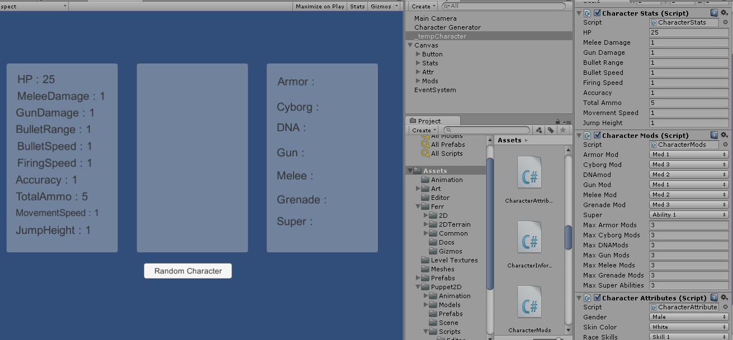

As you can see the _tempCharacter has the 3 scripts attached to it and the UI displays the default stats depending on what is set here. As of right now you can roll the character as many times as you want to get the stats you might like. See below for example:

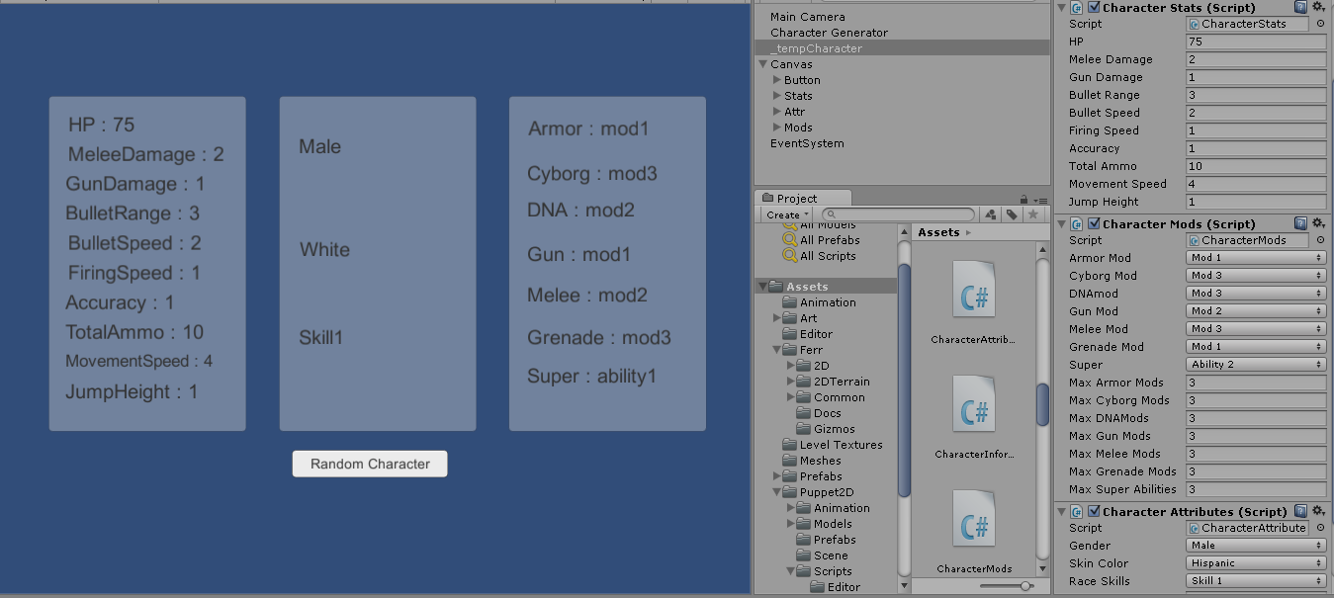

If you look at the scripts on the right you will see that the changes are being made each time you hit random character.